General Information
- Silentia Dimensional baffles are vertical, acoustical baffles made from polyester felt (PET) that is color through. These ceilings are offered in traditional rectangular, wavy and angle styles. See the product data page for dimensions of each type.
- Silentia Dimensional baffles are designed to be installed with heavy duty 15/16” grid or suspended from structure with cable.
Site Conditions
- Baffles can be installed in temperatures between 40°F (4°C) and 158°F (70°C). Baffles not to be used in exterior applications or high moisture environments where water comes in direct contact with the baffle.
- Install only after spaces are enclosed and weathertight, and after all wet work and overhead work have been completed.
- Baffles are engineered for use in seismic areas when installed in accordance with local code requirements.
Storage & Handling
- Do not store or install near an exposed flame, source of heat, or source of ignition.
- Store horizontally in the original carton in a dry, interior space for at least 24 hours. Clean gloves must be used to avoid fingerprints. It is recommended that two people install each 8’ baffle.
Fire Performance
- Silentia baffles achieve Flame Spread Index 25 or less. Smoke Developed Index 450 or less. Class A per ASTM E84. Baffles may interfere with fire sprinkler or fire detection system. Consult a fire protection engineer, NFPA 13, and their local code official for guidance on the proper installation techniques where fire detection or suppression systems are present.
Warranty
- A 1-year limited warranty is available. Please consult www.maxxitgroup.com for details.

Cleaning
- Use a clean, dry, soft, white cloth to wipe off any fingerprints or dust. You can also use a vacuum with an upholstery cleaning attachment. Clean in one direction for best results. A damp cloth and mild detergent can be used for more stubborn dust and dirt. Wipe off afterward with a dry cloth.
Colors
- Silentia offers 35 standard colors. Lot to lot variation in color and grain are common in felt products. To minimize noticeable variation, we recommend ordering attic stock and installing material from separate orders in different areas.
Cutting Baffles
- Silentia felt baffles can be cut with commonly available tools. As a polyester resin (PET) felt is susceptible to melting from frictional heat. The following tools can be used to cut felt.
- Hand tools include; insulation, utility and straight knives. For best finished cut quality make sure you have adequate blade length and use a straight edge.
- Circular saws should use a non-ferrous/plastic blade or a 7-1/4" foam blade. For best finished cut quality use a straight edge guide and maintain a constant feed rate. Stop the blade motion before backing the saw out of the cut.
- High-speed steel drill bits will work for drilling holes in Silentia. Some drill bit designs melt the felt material and will need frequent cleaning. Titaniumcoated HSS drill bits are recommended because they produce less friction than basic HSS bits.
Design
- Baffles have a 1/4" gap between ends of for best visual.
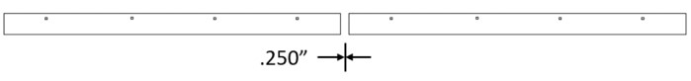

Installation on 15/16" heavy-duty grid Before installing please note:
- Maximum main tee spacing is 48"
- Maximum hanger wire spacing on main tee is 48"

- 15/16" cross tee should not exceed 24" spacing.
- Maximum baffle overhang should not exceed 11.5" from the ends.
- Make sure that the whole system is straight and correctly leveled. - Felt baffles require at least two (2) connection points per baffle.

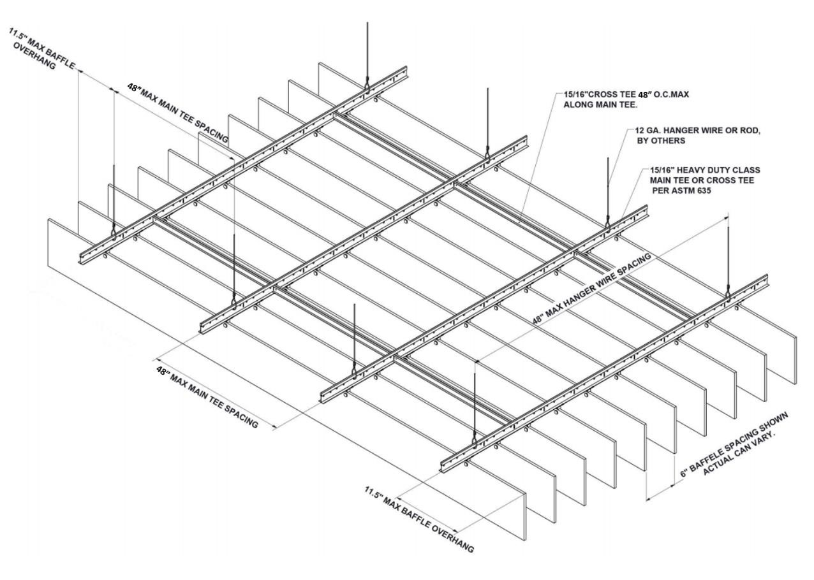

Connecting baffles to 15/16” heavy duty class Grid
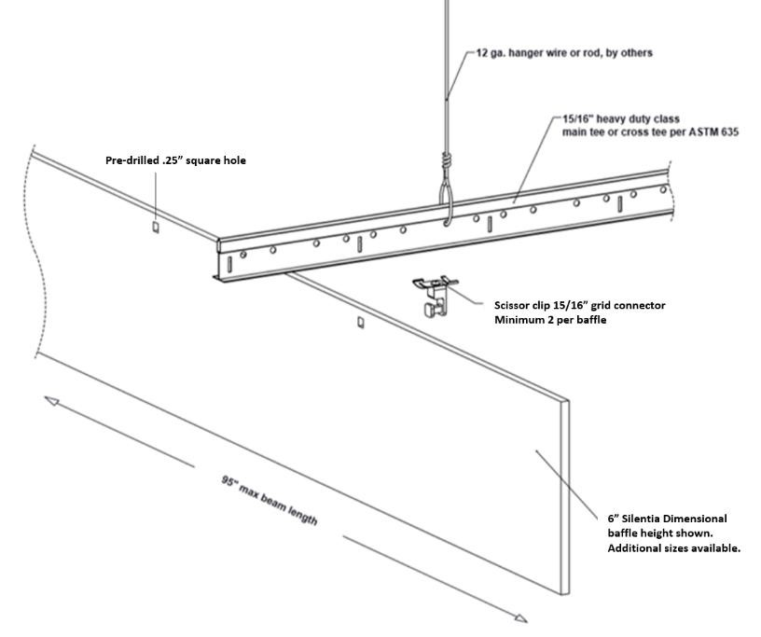
- Insert scissor clip into pre-drilled baffle hole
- Align baffle and scissor clip with desired position on the 15/16’ HD main or cross tee and rotate scissor clip attachement until fully engaged.
Installing baffles with cable (not shown)
- Mark your baffle connecting points on the ceiling structure.
- Connection points on baffle should not exceed 48".
- Maximum baffle overhang should not exceed
11.5".
- Baffles require at least two (2) connection points per baffle.
Cable clips are available for hanging baffles with aircraft
cable from suspension systems or direct to structure.
- Insert cable clip into pre-drilled baffle hole and thread aircraft cable through clip. Cable

provided by others.
- Connection to ceiling structure or suspension systems designed and provided by others.

MEP Integrations

- Mechanical fixtures such as lights and sprinklers can be installed at the suspension system height, flush with the bottom of the baffles, or below the bottom of the baffles. Fixture weight must not
be supported by the felt baffles or HD grid suspension.

Silentia Dimensional Partitions

Installation for direct ceiling mount

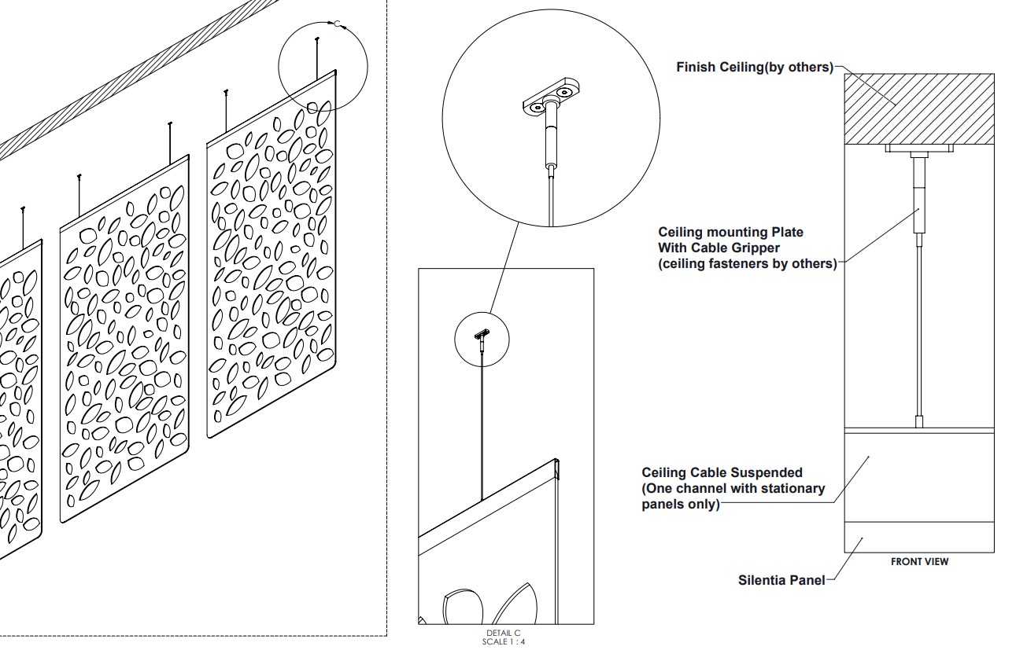
Installation on 15/16" heavy-duty grid

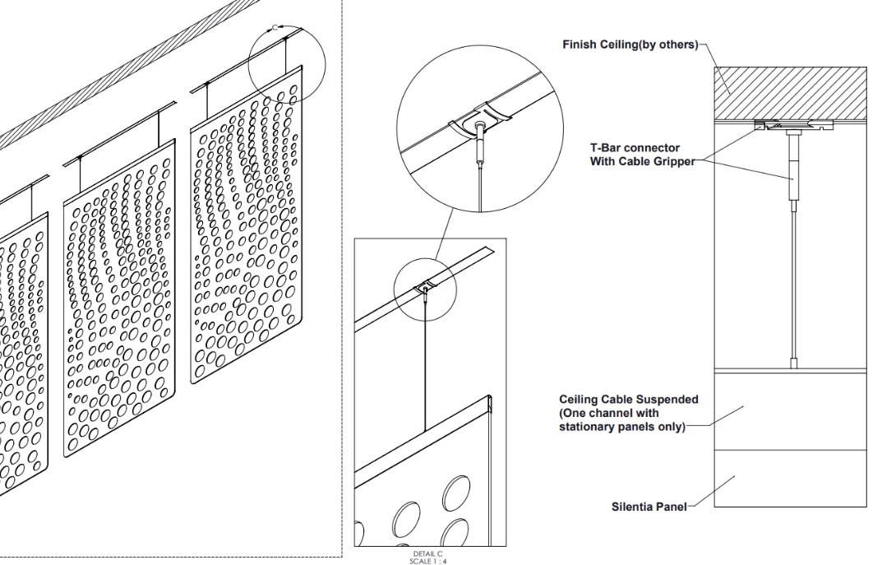

Silentia Wall Art

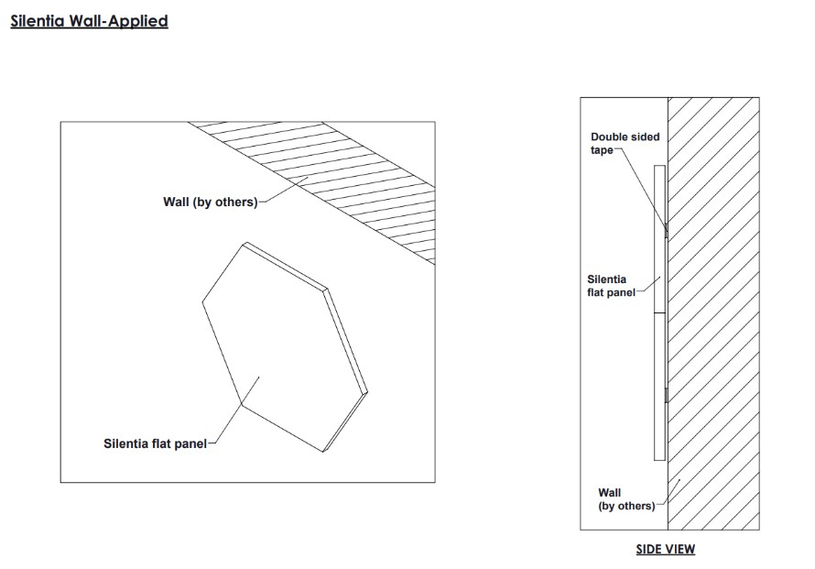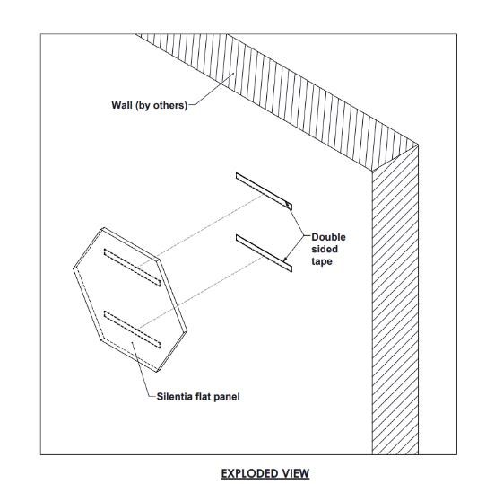

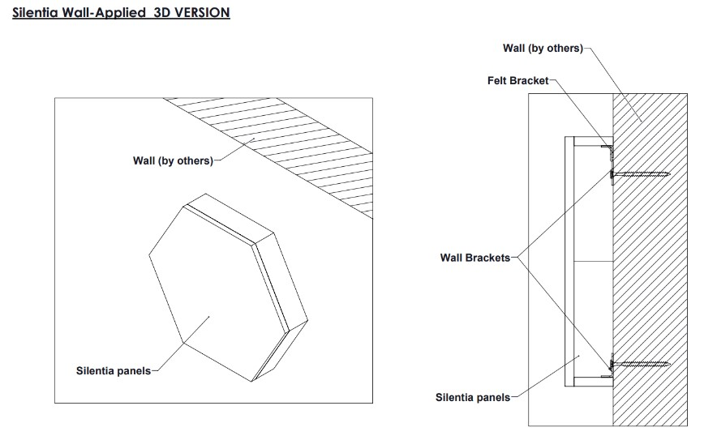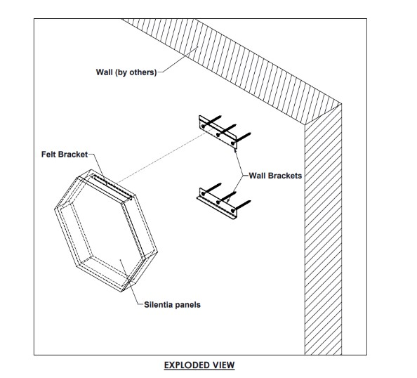

Silentia Clouds
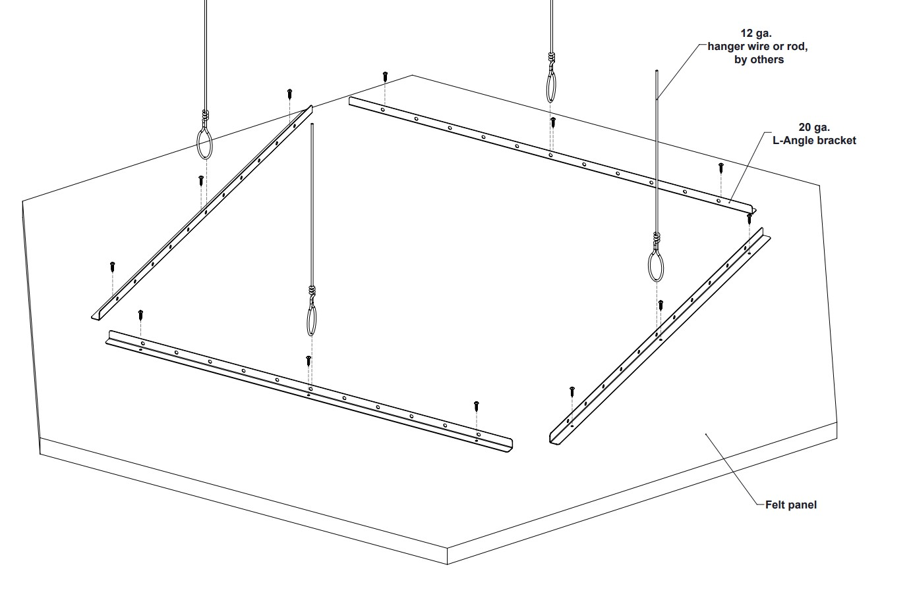

Before installing, please note.
In addition to these instructions please refer to the publications referenced below for full details on industry accepted practices and requirements.
- ClSCA "Ceiling Systems Handbook"

- Standard for Ceiling Suspension System Installations - ASTM C 636
- Standard for Ceiling Suspension Systems Requiring Seismic Restraint - ASTM E 580
- IBC (International Building Code) Standard for Seismic Zone for local area.

For addition question or assistance
Please contact us at: www.maxxitgroup.com

©3/21 Maxxit Systems, Printed in the USA

