General Information
- Silentia Profile baffles are vertical, acoustical baffles made from polyester felt (PET) that is color through. These ceilings are offered in traditional rectangular, elevations, shuffle and angle styles. See the product data page for dimensions of each type.
- Silentia Profile baffles are designed to be installed with heavy duty 15/16” grid, Unistrut or suspended from structure with cable.
- Felt Ceilings are engineered for use in seismic areas when installed in accordance with local code requirements.
Site Conditions
- Baffles can be installed in temperatures between 40°F (4°C) and 158°F (70°C). Baffles not to be used in exterior applications or high moisture environments where water comes in direct contact with the baffle.
- Install only after spaces are enclosed and weathertight, and after all wet work and overhead work have been completed.
- Baffles are engineered for use in seismic areas when installed in accordance with local code requirements.
Storage & Handling
- Do not store or install near an exposed flame, source of heat, or source of ignition.
- Store horizontally in the original carton in a dry, interior space for at least 24 hours. Clean gloves must be used to avoid fingerprints. It is recommended that two people install each 8’ baffle.
Fire Performance
- Silentia baffles achieve Flame Spread Index 25 or less. Smoke Developed Index 450 or less. Class A per ASTM E84. Baffles may interfere with fire sprinkler or fire detection system. Consult a fire protection engineer, NFPA 13, and their local code official for guidance on the proper installation techniques where fire detection or suppression systems are present.
Warranty
- A 1-year limited warranty is available. Please consult www.maxxitgroup.com for details.

Cleaning
- Use a clean, dry, soft, white cloth to wipe off any fingerprints or dust. You can also use a vacuum with an upholstery cleaning attachment. Clean in one direction for best results. A damp cloth and mild detergent can be used for more stubborn dust and dirt. Wipe off afterward with a dry cloth.
Colors
- Silentia offers 35 standard colors. Lot to lot variation in color and grain are common in felt products. To minimize noticeable variation, we recommend ordering attic stock and installing material from separate orders in different areas.
Cutting Baffles
- Silentia felt baffles feature an aluminum channel that can be cut with commonly available tools.
- Additionally: as a polyester resin (PET) felt is susceptible to melting from frictional heat. The following tools can be used to cut felt.
- Hand tools include; insulation, utility and straight knives. For best finished cut quality make sure you have adequate blade length and use a straight edge.
- Circular saws should use a non-ferrous/plastic blade or a 7-1/4" foam blade. For best finished cut quality use a straight edge guide and maintain a constant feed rate. Stop the blade motion before backing the saw out of the cut.
Design
- Profile baffles can be installed with a 1/4" gap between ends for a clean visual.
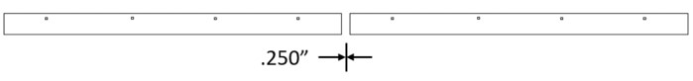
- Profile baffles can be joined with a spline for a continuous appearance. Consult Maxxit for details.

Installation on 15/16" heavy-duty grid. Before installing please note:
- Maximum main tee spacing is 48" • Maximum hanger wire spacing on main tee is 48"
- 15/16" cross tee should not exceed 24" spacing.
- Maximum baffle overhang should not exceed 19" from the ends.
- Make sure that the whole system is straight and correctly leveled.
- Felt baffles require at least two (2) connection points per baffle.

Installation on Unistrut (not shown) Before installing please note:
- Maximum Unistrut spacing is 48"
- Maximum hanger wire spacing on Unistrut is 48"
- Maximum baffle overhang should not exceed 19" from the ends.
- Make sure that the whole system is straight and correctly leveled.
- Felt baffles require at least two (2) connection points per baffle.

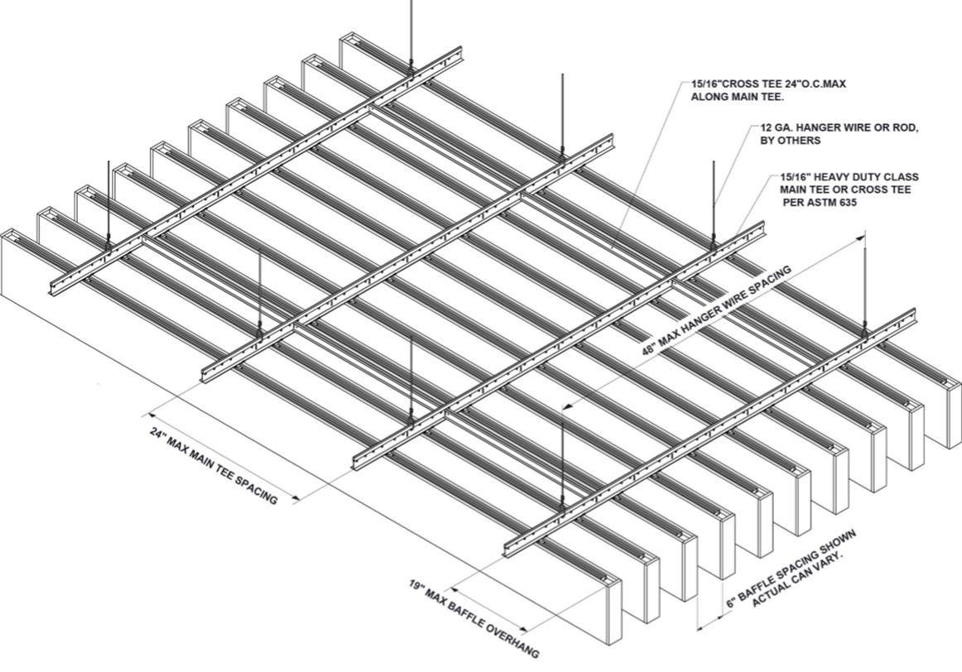

Each baffle is internally reinforced every 2’. If the need arises Profile baffles can be cut to size without sacrificing aesthetics or

performance. End caps can be purchased separately and easily attached.

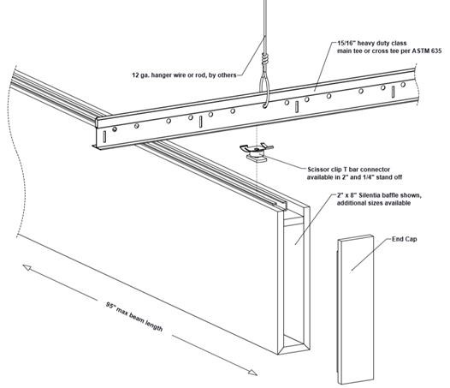
Connecting baffles to 15/16” Heavy Duty Grid
- Insert scissor clip into aluminum baffle channel, slide to desired location and hand tighten nut.
- Align baffle and scissor clip with the desired position on the 15/16’ HD main or cross tee and rotate scissor clip attachement until fully engaged.
- Scissor clips enable easy adjustment during installation and easy plenum access.

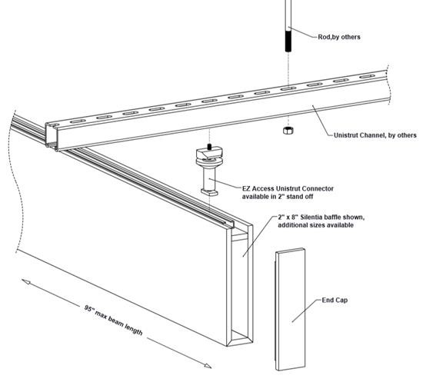
Connecting baffles to Unistrut
- Insert Unistrut connector in aluminum baffle channel, slide connector to the desired location and hand tighten 2” cylinder.
- Align baffle and unistrut connectors with unistrut channels, insert top of connector into channel. Slide to desired location and hand tighten with circular disc.
- Unistrut connector lets you leave baffles in place for adjustments during installation and slide for easy plenum access.

Connecting baffles with aircraft cable
Cable clips are available for hanging baffles with aircraft cable from suspension systems or direct to structure. (not shown)
- Insert cable connector into aluminum baffle channel, slide to desired location and hand tighten cylander.
- Thread aircraft cable through clip and tighten. Cable provided by others.
- Connection to ceiling structure or suspension systems designed and provided by others.
MEP Integrations
- Mechanical fixtures such as lights and sprinklers can be installed at the suspension system height, flush with the bottom of the baffles, or below the bottom of the baffle. Fixture weight must not be supported by the felt baffles or HD grid suspension.
Before installing, please note.
In addition to these instructions please refer to the publications referenced below for full details on industry accepted practices and requirements.
- ClSCA "Ceiling Systems Handbook"
- Standard for Ceiling Suspension System Installations - ASTM C 636
- Standard for Ceiling Suspension Systems Requiring Seismic Restraint - ASTM E 580
- IBC (International Building Code) Standard for Seismic Zone for local area.

Versatile Silentia Profile baffles can be configured into a wide variety of stunning ceiling designs using the same installation methods and connectors.
Silentia | Profile - Shuffle Design
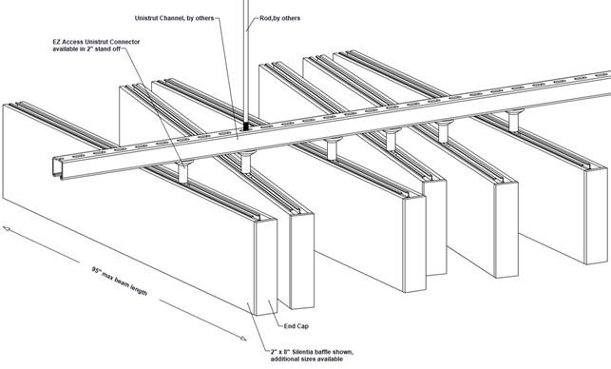

Silentia | Profile – Elevations Design
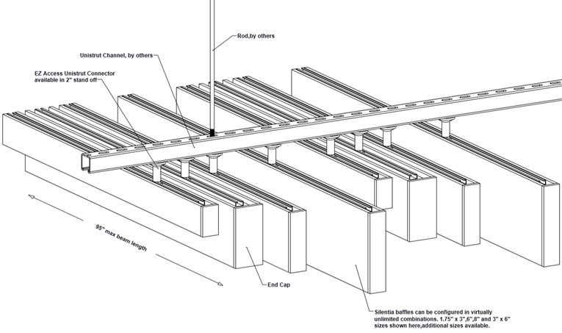

Silentia | Profile – Angle Design
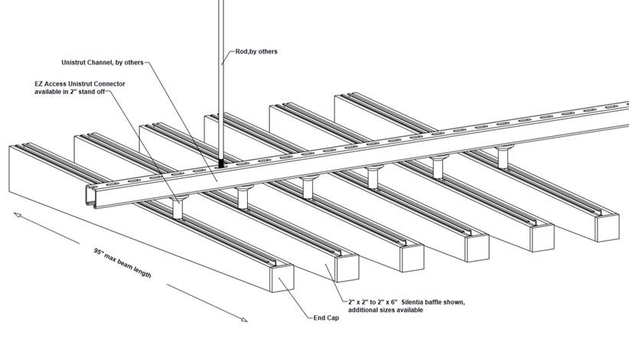

Silentia | Profile Networks

Installation on 15/16" heavy-duty grid. Before installing please note:
- Maximum main tee spacing is 48" • Maximum hanger wire spacing on main tee is 48"
- 15/16" cross tee should not exceed 24" spacing.
- Maximum baffle overhang should not exceed 19" from the ends.
- Make sure that the whole system is straight and correctly leveled.
- Felt baffles require at least two (2) connection points per baffle.

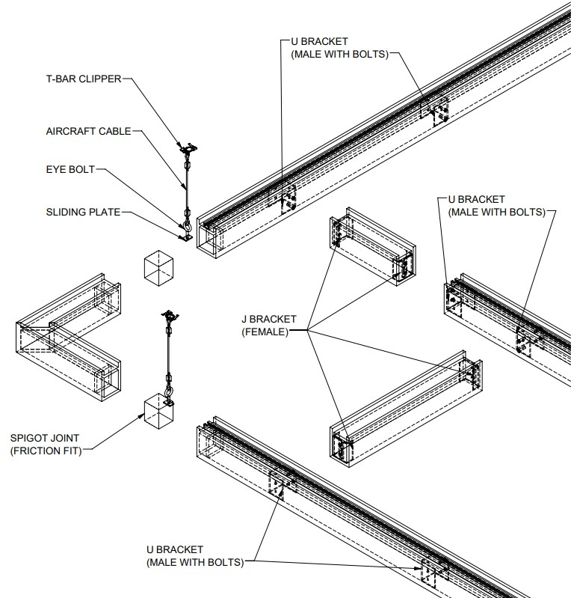

Installation on Unistrut
Before installing please note:
- Maximum Unistrut spacing is 48"
- Maximum hanger wire spacing on Unistrut is 48"
- Maximum baffle overhang should not exceed 19" from the ends.
- Make sure that the whole system is straight and correctly leveled.
- Felt baffles require at least two (2) connection points per baffle.

For addition question or assistance
Please contact us at: www.maxxitgroup.com

©3/21 Maxxit Systems, Printed in the USA

