General Information
- Agilis beams & baffles are vertical & horizontal, fabricated aluminum profiles made from .041” - .060” thick aluminum sheet, design dependent.
- These ceilings are offered in traditional rectangular, elevations & shuffle styles. See the product data page for dimensions of each type.
- Agilis baffles are designed to be installed with heavy duty 15/16” grid, Unistrut or suspended from structure with cable.
- Metal Ceilings are engineered for use in seismic areas when installed in accordance with local code requirements.
Site Conditions
- Baffles not to be used in exterior applications or high moisture environments where water comes in direct contact with the baffle.
- Install only after spaces are enclosed and weather-tight, and after all wet work and overhead work have been completed.
Storage & Handling
- Do not store or install near an exposed flame, source of heat, or source of ignition.
- Store horizontally in the original carton in a dry, interior space. Clean gloves must be used to avoid fingerprints. When removed for install, the vertical panels should be stored in a flat, horizontal position.
- Recommended that two people install each 8’ baffle.
Fire Performance
- Agilis is manufactured to meet ASTM E-84 Class 1 or A fire retardancy. Baffles may interfere with fire sprinkler or fire detection system. Consult a fire protection engineer, NFPA 13, and their local code official for guidance on the proper installation.
Warranty
- A 1-year limited warranty is available. Please consult www.maxxitgroup.com for details.

Colors
- Agilis is made with a factory-applied polyester paint. Available in Standard Colors, Color Matched and Wood Look powder-coated.
- To maximize visual consistency, baffles should be unpacked and examined collectively to determine the most desirable arrangement for installation.
Cutting Baffles
- Agilis baffles are made of aluminum that can be cut with commonly available tools.
- Cut the baffle using standard wood working tools and, where possible, a straight edge. A table saw is recommended for straight cuts and a band saw for curved cuts. In general, these practices will be typical of those employed in finish carpentry.
- Circular saws should use a multi-purpose blade. For best finished cut quality use a straight edge guide and maintain a constant feed rate. Stop the blade motion before backing the saw out of the cut.
Design
- Baffles can be installed with a 1/4" gap between ends for a clean visual.
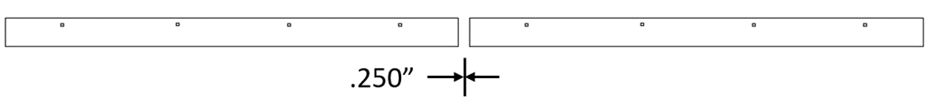
- Baffles can be joined with a spline for a continuous appearance. Consult Maxxit for details.

Installation on 15/16" heavy-duty grid.
Before installing please note:
- Maximum main tee spacing is 48"
- Maximum hanger wire spacing on main tee is 48"
- 15/16" cross tee should not exceed 24" spacing.
- Maximum baffle overhang should not exceed 19" from the ends.
- Make sure that the whole system is straight and correctly leveled.
- Baffles require at least two (2) connection points per baffle.

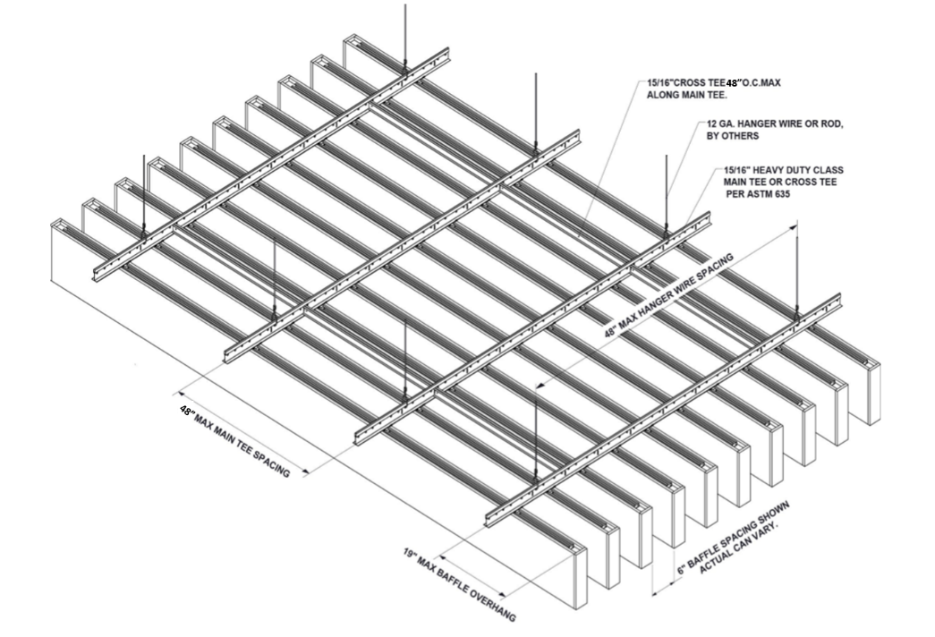

If the need arises baffles can be cut to size without sacrificing aesthetics or performance. End caps can be purchased separately and easily attached.

Installation on Unistrut (not shown)
Before installing please note:
- Maximum Unistrut spacing is 48"
- Maximum hanger wire spacing on Unistrut is 48"
- Maximum baffle overhang should not exceed 19" from the ends.
- Make sure that the whole system is straight and correctly leveled.
- Baffles require at least two (2) connection points per baffle.

Connecting baffles to 15/16” Heavy Duty Grid
- Insert scissor clip into aluminum baffle channel, slide to desired location and hand tighten nut.
- Align baffle and scissor clip with the desired position on the 15/16’ HD main or cross tee and rotate scissor clip attachement until fully engaged.
- Scissor clips enable easy adjustment during installation and easy plenum access.

Connecting baffles to Unistrut
- Insert Unistrut connector in aluminum baffle channel, slide connector to the desired location and hand tighten 2” cylinder.
- Align baffle and unistrut connectors with unistrut channels, insert top of connector into channel. Slide to desired location and hand tighten with circular disc.
- A Unistrut connector is also available that can be inserted directly into the unistrut channel from below and then tightened.
- Unistrut connector lets you leave baffles in place for adjustments during installation and slide for easy plenum access.

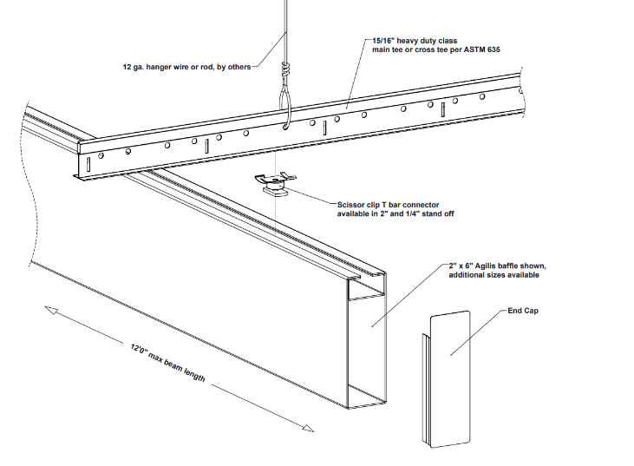

Continued;
Connecting baffles with aircraft cable
Cable clips are available for hanging baffles with aircraft cable from suspension systems or direct to structure. (not shown)
- Insert cable connector into aluminum baffle channel, slide to desired location and hand tighten cylander.
- Thread aircraft cable through clip and tighten. Cable provided by others.
- Connection to ceiling structure or suspension systems designed and provided by others.

Versatile Agilis baffles can be configured into a wide variety of stunning ceiling designs using the same installation methods and connectors.

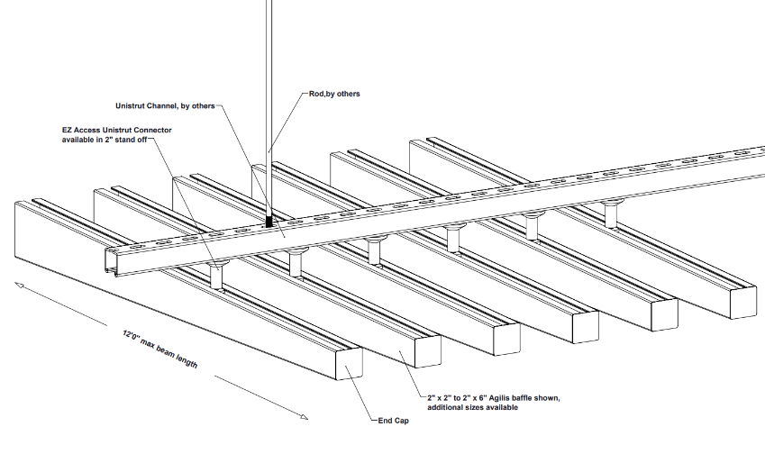
Agilis – Angle Design

Agilis -Shuffle Design
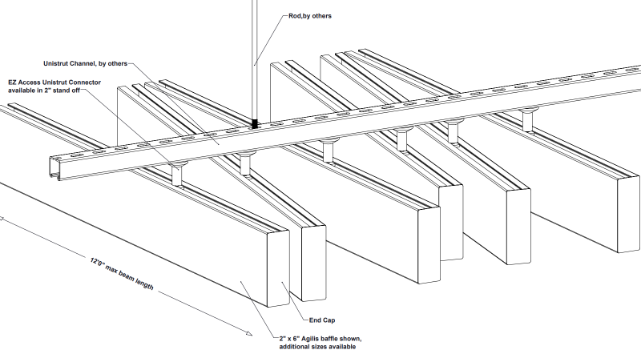

Agilis – Elevations Design
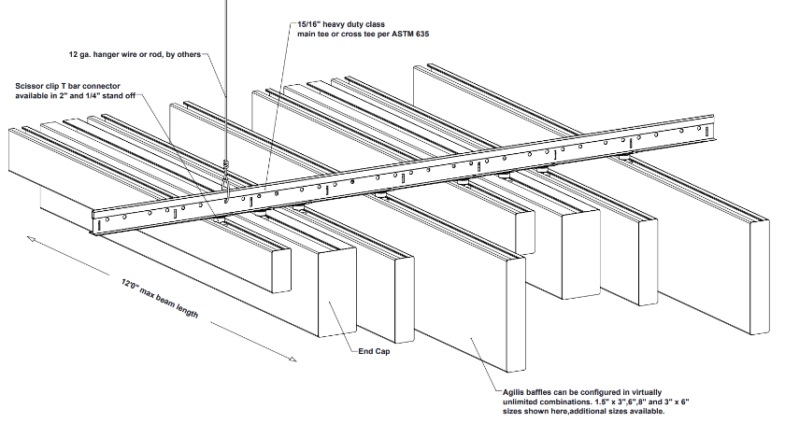

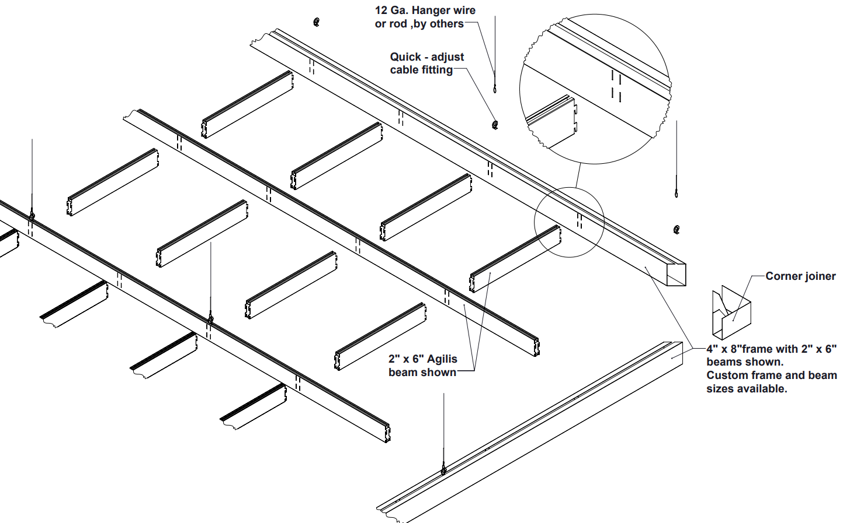
Agilis Networks

Installation on Unistrut and 15/16’’ heavy-duty grid.
Before installing please note:
- Maximum Unistrut spacing is 48"
- Maximum hanger wire spacing on Unistrut is 48"
- 15/16" cross tee should not exceed 24" spacing.
- Maximum baffle overhang should not exceed 19" from the ends.
- Make sure that the whole system is straight and correctly leveled.
- Baffles require at least two (2) connection points per baffle.

Agilis Crossroads

Creates open cell designs that can be configured to architectural elements and special consideration.

MEP Integrations
- Mechanical fixtures such as lights and sprinklers can be installed at the suspension system height, flush with the bottom of the baffles, or below the bottom of the baffle. Fixture weight must not be supported by the felt baffles or HD grid suspension.
Before installing, please note.
In addition to these instructions please refer to the publications referenced below for full details on industry accepted practices and requirements.
- ClSCA "Ceiling Systems Handbook"
- Standard for Ceiling Suspension System Installations - ASTM C 636
- Standard for Ceiling Suspension Systems Requiring Seismic Restraint - ASTM E 580
- IBC (International Building Code) Standard for Seismic Zone for local area.

For addition question or assistance
Please contact us at: www.maxxitgroup.com

